
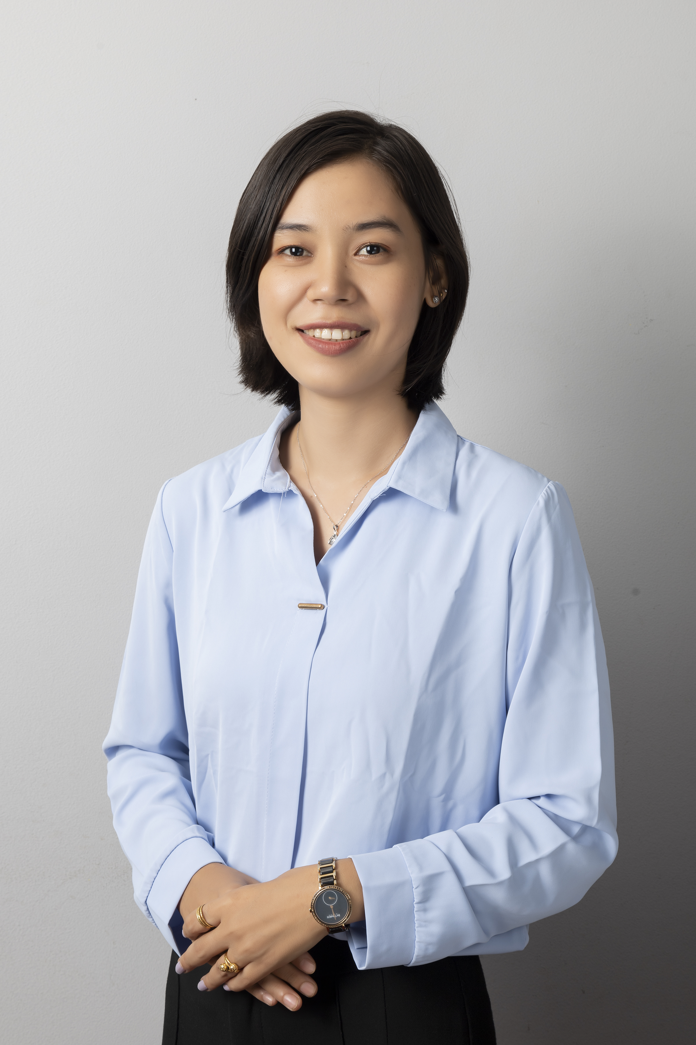
Career
Objective
Lai Phyu San
Quantity Surveyor
Contact
Personal Information
JOB EXPERIENCE
NAME
DESIGNATION
3657
NAME
DESIGNATION
COMPANY NAME
3657
Traction Street
Charlotte, SC 28217
- Quantity Surveying
Singapore Standard Method
(SQS Training Center )
- ETAB & SAFE
- RC Building Estimate
- Construction Management
- Technical English
- (Build Bright Engineering )

- Bachelor of Engineering (Civil)
Technological University(KALAY)
( Dec 2009 ~ Nov 2014 )

DOB : 7 April 1993
Passport No : MF734594
Gender : Female
Marital Status : Single
Nationality : Myanmar
Availability : Immediately
Expected Salary : SGD 2500

+959254167214 (WhatsApp)

laiphyusan.qs07@gmail.com

No.585, Nwethargi Street,
Yangon, Myanmar,11421

Education
Other Certification

Royal Golden Gangaw Co., Ltd Dec 2018 – Nov 2022
Quantity Surveyor cum Drafter Yangon, Myanmar

Duties and Responsibilities,
- Assembled pre-contract cost estimates, cost plans, tender documents, interim payments, variation order and monthly progress claims.
- Took off quantity of projects and measurement by reviewing tender drawings and construction drawings.
- Checked, proceeded, arranged and tabulated the material orders and budget monitoring through the entire life cycle project.
- Prepared and submitted client quotation and tender enquires as and when.
- Provided in procurement processes including the production and issuing of tender enquires.
- Assisted with liaising with clients, sub-contractors and suppliers to identify their agreements.
- Measured and evaluated the variation of quality, quantity and job scope changes.
- Designed and drew the proposed and tender drawing for building construction.
- Attended meeting and providing contractual advice and Contractual Claims management.
- Coached guidance on SOP (Standard Operating Procedures) to the juniors.

I would like to seek a position in which managerial and engineering expertise can be put to good use. I have graduated Bachelor of Civil Engineering and seven years experiences want to apply my skills properly in the QS position as well as enhance my knowledge by exploring new things.

Radiant Construction CO., Ltd Sept 2016 – Nov 2018
Quantity Surveyor cum Site Engineer Monywa, Myanmar
Duties and Responsibilities,
- Arranged and planned complete budget for new project with related infrastructures and enhancement for other infrastructures along project area.
- Assisted in the preparation of reports for contract review meeting.
- Prepared and updated daily and weekly progress report regularly according to master work program under department guidelines.
- Gathered tender documents and checked for completeness which include specifications, drawings, commercial requirements, and technical requirements.
- Verified material and labour bills prepared by relevant project engineer on fortnightly basis on ERP.

English
Myanmar
BOOK READING
SWIMMING
TREWELLING
MUSIC LISTENING
NAME
DESIGNATION
COMPANY NAME
NAME
DESIGNATION
COMPANY NAME
3657
Traction Street
Charlotte, SC 28217
Software Skills

Language

KMG Construction Co., Ltd March 2015 – Aug 2016
Site Engineer Kalay , Myanmar

Duties and Responsibilities,
- Analysed drawings, specifications and calculated the estimate of working project due to the given structure.
- Performed on site supervision for workmanship and quality control.
- Handled and solved the site delaying technical and engineering problems.
- Carried out measurement in various trades e.g. concrete, rebar, steel structures and architectural finishes.
- Provided guidance to supervisors in relation to construction works, ensure progress according to schedule.
- Reported back to Senior Engineer for daily site activities planning, preparing work breakdown, daily site operations, monitoring, and report work progress.

Bituminous Road, Bally Bridge with bored pile foundation & RC Bridge Projects
Summary
- Microsoft Office
(Excel, Word, Power point)
- AutoCAD 2D
- Sketchup
- Microsoft Project
(Construction Project Scheduling & Cost Control)

I am a highly talented and dedicated Civil Engineer which I can apply my experience and knowledge can be contributed to constructions company’s growth as well.
I hereby declare that the above information mentioned is true and complete to the best of my knowledge.
Thanks, for your attention. I am looking forward to hear from your quickly reply soon.

With Respect,
Lai Phyu San
+959 254 167 214 (WhatsApp)

- Fast learner and physically fit
- Creative, innovative ideas
and problem-solving skills
- Good at time management
- Able to work well with team
- Excellent skill in working under pressure

Personal Strength
RC Residential Building ,University Convocation Hall & Classroom Projects

